**Step 1: Drawing Basic Shapes With Python Turtle**

1. Create an new Repl by selecting the **“Python with Turtle”** language / environment.

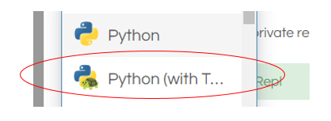

1. Begin all of your turtle programs with the following code to create a “pen”:

import turtle

myPen = turtle.Turtle()

1. Review the following chart for a list of Turtle commands.

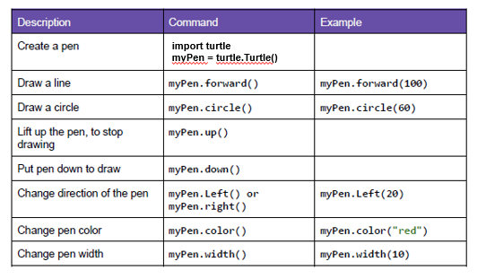

1. Use the following program to draw a red square.

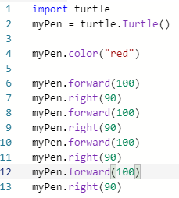

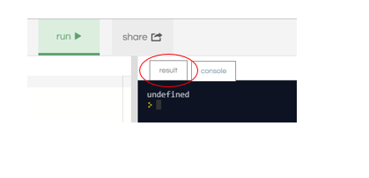

1. Switch to the “Result” window to see the square.
2. Create a program to draw any one of the shapes “b”, ”d”, or “e” shown in the figures below.   
   Provide a listing of your program code.
3. Create a program to draw any one of the shapes “c”, or “f” shown in the figures below.   
   Provide a listing of your program code.

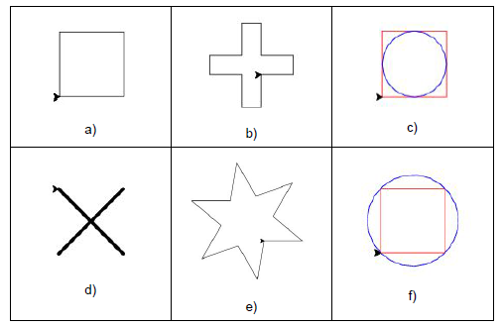

**Step 2: Christmas / Winter Theme Card**

1. Use your creativity to create a card design using Turtle.
   1. The design must have multiple figures.
   2. The design must have at least two different patterns.
   3. You may repeat patterns.
   4. Provide a listing of your program code.
   5. Provide an image of your program result.
2. import turtle
4. t = turtle.Turtle()
6. def draw_circle(color, radius, x, y):
7. t.penup()
8. t.fillcolor(color)
9. t.goto(x,y)
10. t.pendown()
11. t.begin_fill()
12. t.circle(radius)
13. t.end_fill()
15. draw_circle("#77afde", 60, 0, -40)
16. draw_circle("#77afde", 40, 0, -100)
17. draw_circle("#77afde", 60, 0, -200)
19. draw_circle("#82ab73", 5, -20, 20)
20. draw_circle("#82ab73", 5, 20, 20)
21. draw_circle("#FF6600", 3, 0, 15)
22. draw_circle("#ffffff", 2, 0, -35)
23. draw_circle("#ffffff", 2, 0, -45)
24. draw_circle("#ffffff", 2, 0, -55)
26. t.penup()
27. t.goto(-18,-35)
28. t.pendown()
29. t.pensize(5)
30. t.goto(-75, -50)
31. t.penup()
32. t.goto(18,-35)
33. t.pendown()
34. t.pensize(5)
35. t.goto(75, -50)
36. t.penup()
37. t.goto(0,-3)
38. t.pendown()
39. t.pensize(3)
40. t.goto(0,-15)

